


Thesis Title

By

Student Name
A Thesis Presented to the
Department of
KING FAHD UNIVERSITY OF PETROLEUM AND MINERALS

DHAHRAN, SAUDI ARABIA

In Partial Fulfilment of the Requirements for the
Undergraduate Research Concentration
May 2026

***Please remember to resolve/delete all Notes and Example Text in red and yellow highlights throughout the template before saving and submitting your dissertation.

COMPLETE TITLE OF THE UNDERCRAUTE RESEARCH THESIS

STUDENT’S FULL NAME
A Thesis Submitted in Partial Fulfillment of the Requirements for the Undergraduate Research Concentration

UNDERGRADUATE MAJOR
DEPARTMENT’S NAME
MONTH AND YEAR OF DEFENSE

KING FAHD UNIVERSITY OF PETROLEUM & MINERALS
DHAHRAN- 31261, SAUDI ARABIA
Department of

This thesis, written by STUDENT’S NAME under the direction of his/her thesis advisor and approved by his/her thesis committee, has been presented and accepted by the Chairman, DEPARTMENT’S NAME, in partial fulfillment of the requirements for the Undergraduate Research Concentration.

Dr. [Full Name]  Advisor  Signature: ______________________  Dr. [Full Name]  Examiner 2  Signature: ______________________ | Dr. [Full Name]  Examiner 1  Signature: ______________________  Dr. [Full Name]  Department Chairman  Signature: ______________________

__________________
Date

© Type Student’s Name
Type Year

Dedication

To

my parents and friends

in recognition of their worth

NOTE: The Dedication page is optional. Any format for justification, spacing, writing style, text size and text font is acceptable for this page; however, all text must fit within the 1-inch page margins.

If you choose not to include a Dedication page, delete this page. The Table of Contents will begin on page ii.

ACKNOWLEDGMENTS
This page is required. Its customary and good manners to say thank you. Keep in mind that one has to use one’s own words when writing an acknowledgement. Plagiarism is unauthorized.

TABLE OF CONTENTS
The text in red is provided as guidance only and should be removed.
The Table of Contents should be created automatically in Microsoft Word using the References tools. Chapter titles and section headings must be formatted using proper heading styles so they are included in the Table of Contents.

It can be updated easily during revisions by right-clicking and selecting “Update Field,” which automatically refreshes page numbers and headings without needing to manually edit or retype anything.

ACKNOWLEDGMENTS iii
TABLE OF CONTENTS iv
LIST OF TABLES v
LIST OF FIGURES vi
LIST OF ABBREVIATIONS vii
ABSTRACT viii
CHAPTER 1 INTRODUCTION 1
1.1 Section Title 1
1.2 Section Title 3
1.2.1 Sub-Section Title 3
1.3 Section Title 3
CHAPTER 2 LITERATURE REVIEW 4
2.1 Section Title 4
2.1.1 Sub-Section Title 4
CHAPTER 3 RESULTS 5
3.1 Section Title 5
3.2 Section Title 6
3.3 Section Title 6
CHAPTER 4 CONCLUSION 7
REFERENCES 8
APPENDIXS 9

LIST OF TABLES
The text in red is provided as guidance only and should be removed.

Use References → Insert Caption and select the label “Table” when adding table titles.
Generate the List of Tables using References → Insert Table of Figures, then choose “Table” as the caption label.

To update the List of Tables:
Right-click anywhere in the list
Select “Update Field” → “Update Entire Table”

To update all fields (Table of Contents, List of Figures, and List of Tables):
Press Ctrl + A, then F9
Note: Tables are numbered automatically. Do not renumber them manually

Table 1 Test Matrix 1
Table 2 Measurements of System Performance Under Different Loads 3

LIST OF FIGURES
The text in red is provided as guidance only and should be removed.

Add captions to all figures using References → Insert Caption, and select the label “Figure.”
Place the cursor where you want the List of Figures (usually after the Table of Contents).
Go to References → Insert Table of Figures.
In the dialog box, choose “Figure” as the caption label, then click OK.

To update the List of Figures:
Right-click anywhere in the list
Select “Update Field” → “Update Entire Table”
To update all fields (Table of Contents, List of Figures, List of Tables):
Press Ctrl + A, then F9

Note:
Figures are numbered automatically—do not renumber manually.
Ensure all figures use captions; otherwise, they will not appear in the list.

Figure 1 Dowel bars used in the study 2
Figure 2 Sankey diagram: test matrix 3

LIST OF ABBREVIATIONS
Please remove the text in red, which is given only as a guide.
Enter the list of Acronyms / Abbreviations in alphabetical order. Few examples are shown in the following

AI : Artificial Intelligence
CPU : Central Processing Unit
GPU : Graphics Processing Unit
IoT : Internet of Things
ML : Machine Learning

ABSTRACT

Full Name | : | [Type Student’s Full Name]
Thesis Title | : | [Type Complete Thesis Title]
Major Field | : | [Type Major]
The abstract is a concise summary of your undergraduate research thesis. It typically ranges from 200 to 250 words and should not exceed one page.

Although written last, the abstract is one of the most important sections of the thesis. It should clearly present:
- The background of the study
- The purpose or objective of the research
- The methodology used
- The key findings
- The main conclusions and implications

The abstract should be written as a single, continuous paragraph. It should not include citations, references, or detailed discussion.

In summary, the abstract should answer the following questions:
- Why is this research important?
- What was done?
- How was it done?
- What were the main findings?
- What do the results mean?

CHAPTER 1
INTRODUCTION
Set Roman numerals (i, ii, iii) for previous pages. After your Abstract, the page numbers reset at 1, 2, 3.
The chapters are divided into sections where each section is numbered as shown in the following. Each subsequent subsection will have a next order heading.

The introduction chapter presents the research problem, explains its importance, and outlines the study’s goals and approach. It also highlights gaps in existing research and may include specific objectives or defer them to later chapters.

The chapter typically ends with an overview of the thesis structure, briefly describing the content of each chapter. Overall, Chapter 1 establishes what the research is about, why it matters, and what the study aims to achieve, while setting the foundation for the rest of the thesis. The introduction is organized into sections and subsections using numbered headings. Each subsection provides more detailed discussion of specific aspects of the topic and should be clearly aligned with the main objectives of the research. Proper use of subsections helps improve clarity, structure, and logical flow throughout the chapter.

  - Section Title
Provide context for the research topic. Explain the general area of study, recent developments, and why the topic is important. Support statements with references where appropriate.
Figures should be inserted using MS Word’s Insert tool and placed appropriately in the text. Each figure must include a caption placed below the image using the built-in “Caption” style to ensure automatic generation of the List of Figures. Additionally, all images must include alt-text for accessibility, which can be added by right-clicking the image and selecting “View Alt Text.
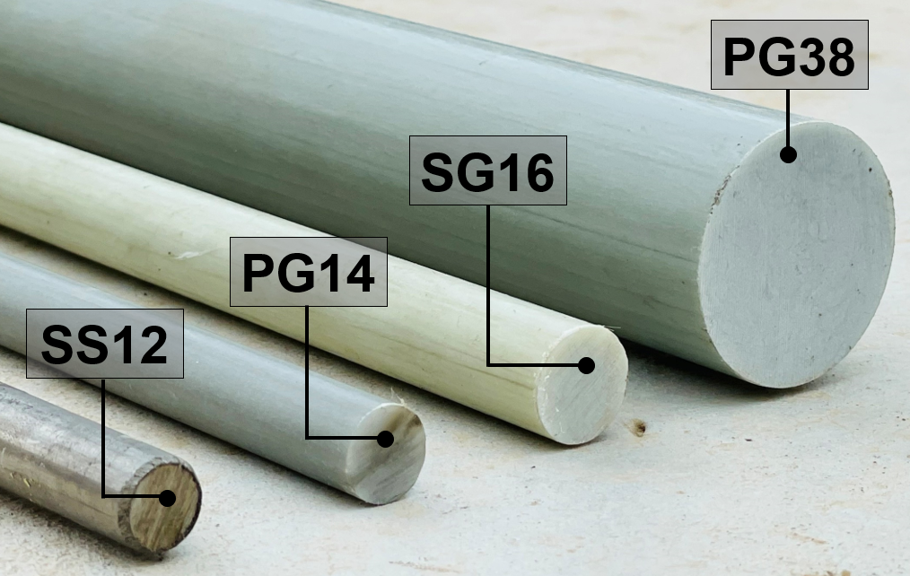
Figure 1 Dowel bars used in the study

  - Section Title
The text in red is provided as guidance only and should be removed. These paragraphs use the “thesis-body text” style that is set for Times New Roman, 12 point font with double spaced lines and extra spacing between paragraphs (no need for hard carriage returns
Clearly define the problem being addressed. Explain the limitations or challenges in existing methods and why they need improvement
    - Sub-Section Title
The text in red is provided as guidance only and should be removed.
Identify what is missing in current research. Explain how your work addresses this gap
  - Section Title
The text in red is provided as guidance only and should be removed.

CHAPTER 2
LITERATURE REVIEW
Chapter 2 provides the theoretical background of the study and reviews relevant previous research related to the topic. It explains existing knowledge to support the research objectives, hypothesis/questions, and methods, and helps identify gaps in the literature that the study aims to address.
This chapter is also used as a structural example for organizing future chapters, including the use of numbered sections and subsections. It may include equations where necessary, inserted using MS Word’s equation tools and properly numbered.
Overall, the literature review establishes the foundation for the study by linking the research problem to existing work and justifying the need for the current investigation.

  - Section Title
The text in red is provided as guidance only and should be removed.

    - Sub-Section Title
The text in red is provided as guidance only and should be removed.

CHAPTER 3
RESULTS
The text in red is provided as guidance only and should be removed.
This chapter presents and explains the results of the research and discusses their meaning. In many theses, results and discussion are combined and organized based on the topic being studied.
The results section should clearly describe the conditions under which data were collected, including what variables were kept constant and what factors were considered. Appropriate analysis and statistical methods should be used where needed. The discussion explains what the results mean, how they relate to previous studies, and whether they support or differ from existing theories. It may also highlight new findings, insights, or possible explanations. Overall, this chapter not only presents the findings but also interprets their significance and contribution to the field, including any broader implications beyond the original research questions

  - Section Title
- The text in red is provided as guidance only and should be removed.
- Table captions should be placed above the table and formatted using the “Caption” style so they can automatically appear in the List of Tables. Captions are preferably single-spaced, especially if they are long (more than four lines), to maintain consistent and clean formatting.

- Table 1 Test Matrix
Sl. No. | Specimen ID | Dowel type | Dowel spacing (mm) | Dowel length (mm) | Dowel end-fixity | Loading scheme
1 | PG14-450-200S-X-X | PG14 | 200 | 450 | X-X | Monotonic
2 | PG14-450-F-XL | PG14 | 250 | 450 | F-XL | Monotonic
3 | PG14-900-F-XL | PG14 | 250 | 900 | F-XL | Monotonic
4 | SG16-450-F-XL | SG16 | 250 | 450 | F-XL | Monotonic

Insert equations using Insert → Equation in Microsoft Word and place them on a separate centered line. Number all equations automatically using chapter-based numbering (e.g., (3.1), (3.2)) with numbers aligned to the right margin; do not type numbers manually. Each equation must be referenced in the text using cross-referencing (References → Cross-reference) instead of manual numbering, and equations should be written in the same font and size as the main text without special formatting.
As shown in Equation (2.1), energy is directly proportional to mass.
$$\begin{aligned}A=πr^{2} \#\left(3.1\right)\end{aligned}$$
$$\begin{aligned}a^{2}+b^{2}=c^{2} \#\left(3.2\right)\end{aligned}$$

  - Section Title

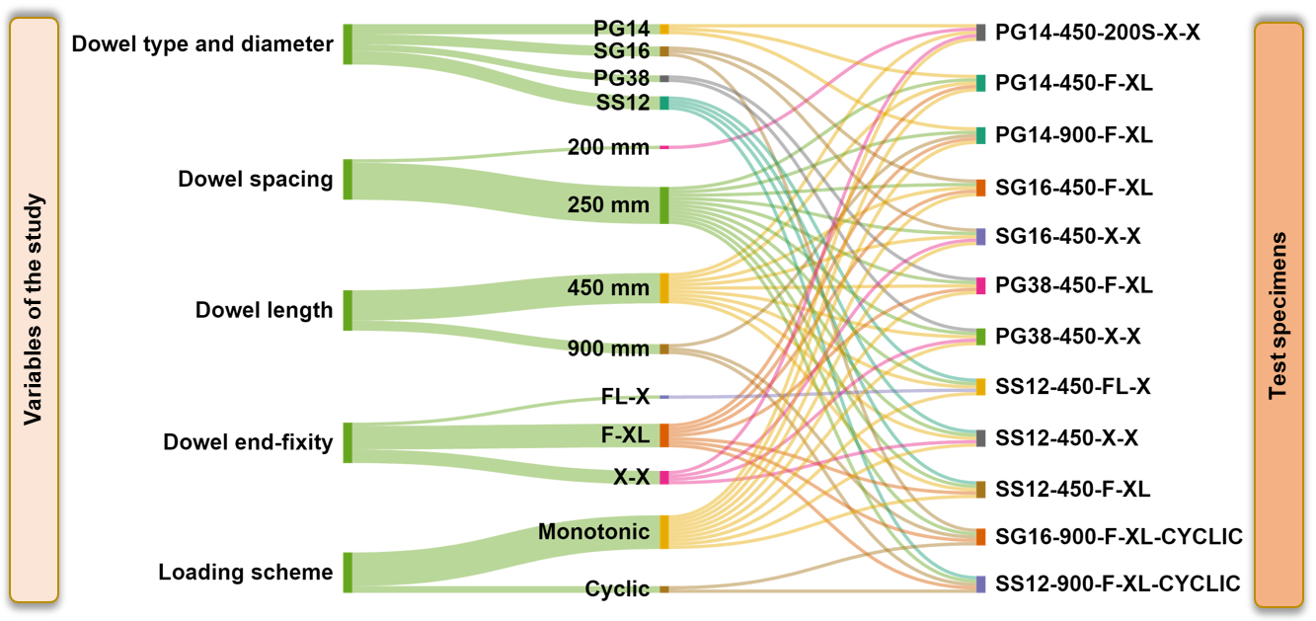
Figure 2 Sankey diagram: test matrix

  - Section Title

Table 2 Measurements of System Performance Under Different Loads
Test case | Input Load  (requests/sec) | Response Time  (ms) | CPU Usage  (%) | Memory Usage (MB)
1
2
3

CHAPTER 4
CONCLUSION
The text in red is provided as guidance only and should be removed. This chapter presents the overall conclusions drawn from the research findings and discusses their broader significance. It synthesizes the key results and highlights how they address the research objectives and questions. The conclusion should clearly summarize the main findings without repeating detailed data, focusing instead on the most important outcomes of the study. It should emphasize how these findings contribute to the existing body of knowledge and whether they support or challenge previous studies or established theories.
In addition, this chapter may outline the practical or theoretical implications of the research, demonstrating its relevance beyond the immediate study. It can also acknowledge any limitations encountered during the research and suggest areas for future investigation. Overall, the conclusion chapter not only brings closure to the study but also reinforces its value, significance, and contribution to the field

REFERENCES
Please remove the texts in red which is given only as a guide.
Management software such as EndNote, Mendely, Zotero can be used for listing the references.
The following is an example of writing the references which have been referenced to in the Thesis.
[1] K. Khalil, Nonlinear Systems, 3rd ed. Upper Saddle River, NJ: Prentice Hall, 2002.
[2] A. V. Oppenheim and R. W. Schafer, Discrete-Time Signal Processing, 3rd ed. Upper Saddle River, NJ: Pearson, 2010
[3] J. G. Proakis and M. Salehi, Digital Communications, 5th ed. New York, NY: McGraw-Hill, 20

APPENDIX
Please remove the texts in red which is given only as a guide.

The appendix includes supplementary materials that support the research but are not essential to the main text.
It should be used for content such as raw data, questionnaires, detailed calculations, or additional tables and figures that would interrupt the flow if included in the main chapters.
Each appendix should be labeled (e.g., Appendix A, Appendix B) and given a clear title. All appendices must be referred to in the main text (e.g., “see Appendix A”).

Overall, the appendix provides additional detail while keeping the main content clear and concise

